**“Swagger” task**

1. Follow the link to Swagger: <https://petstore.swagger.io/>

**2. Create a User via:**



Open the tab -> Click “Try it out” -> Edit the Body with appropriate type of data -> Click “Execute”

Response:

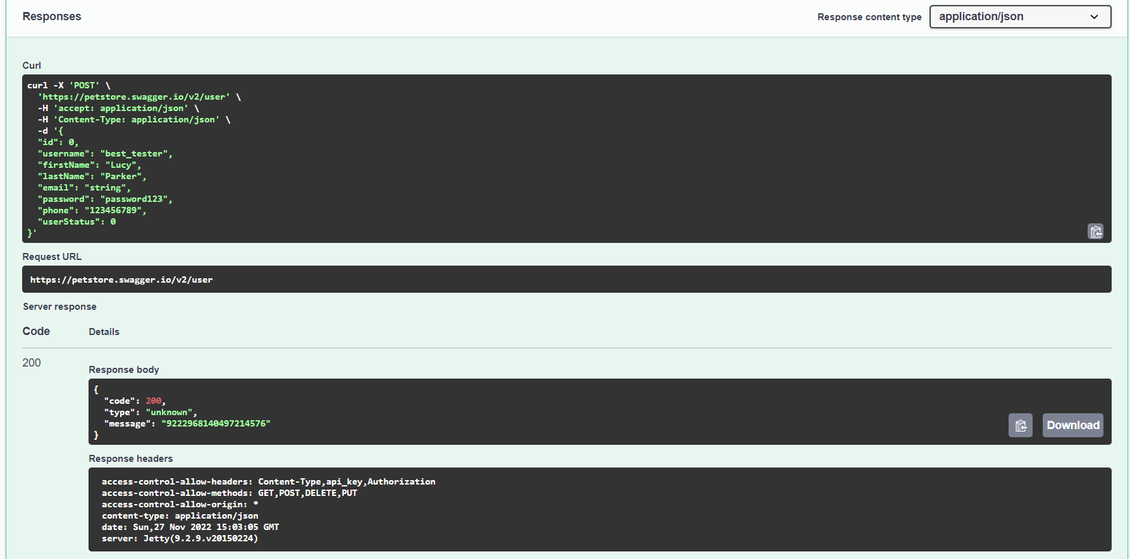

**3. Get information about a created user by the username**



Open the tab -> Click “Try it out” -> Edit the parameter “username” -> Click “Execute”

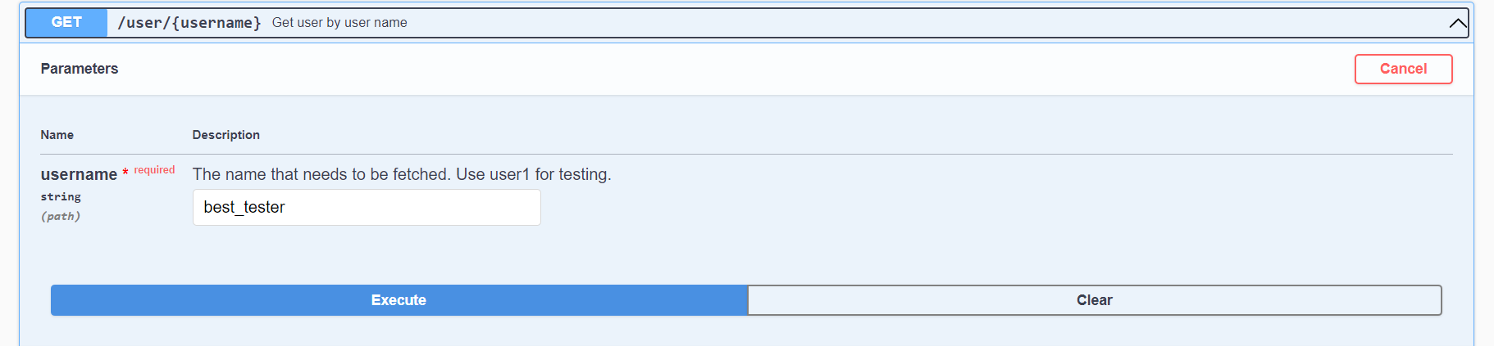

Response:

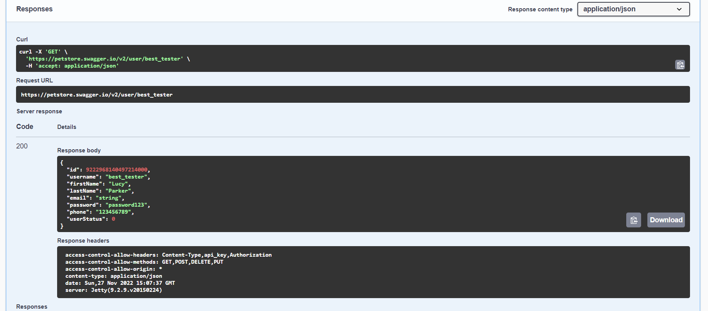

**4. Update the information about a created user**



Open the tab -> Click “Try it out” -> Insert the username -> Edit the Body with appropriate type of data -> Click “Execute”

I’ve changed the First name, the Last name and the password.

Response:

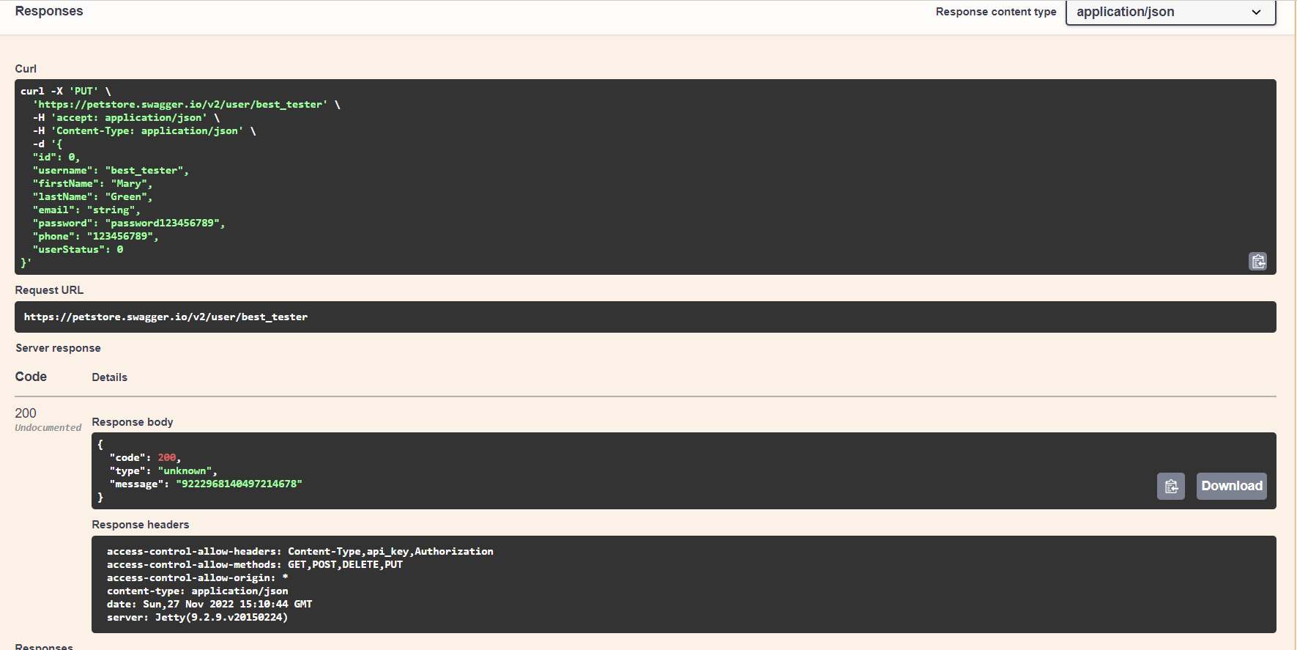

**4. Delete a created user**



Open the tab -> Click “Try it out” -> Insert the username -> Click “Execute”

**Send the performed task as a .docx file with all screenshots of your requests or and archive with the screenshots.**